**Infosys training**

**Hands on assignment**

**Employee Management System**

* URL main:

<http://group3loadbalancer-1874871822.us-west-2.elb.amazonaws.com/awsemp/>

* Creating RDB

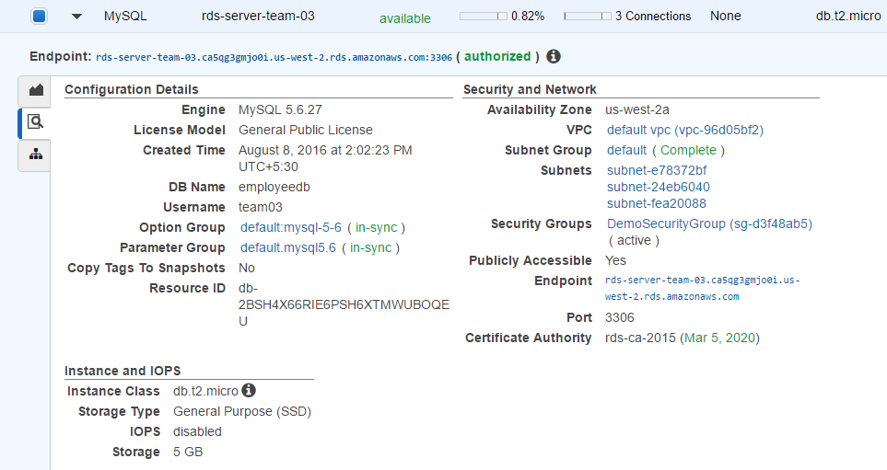

* After setting up environment MySql quarries :

1. Creating table

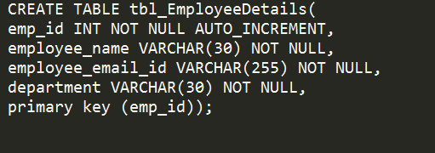

1. Checking if the table has been made.

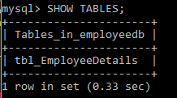

1. Entering employee details.

C:\Users\heman\AppData\Local\Microsoft\Windows\INetCache\Content.Word\Entering employee data.png

1. Get all values

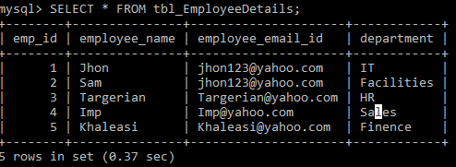

* Ec2 instance

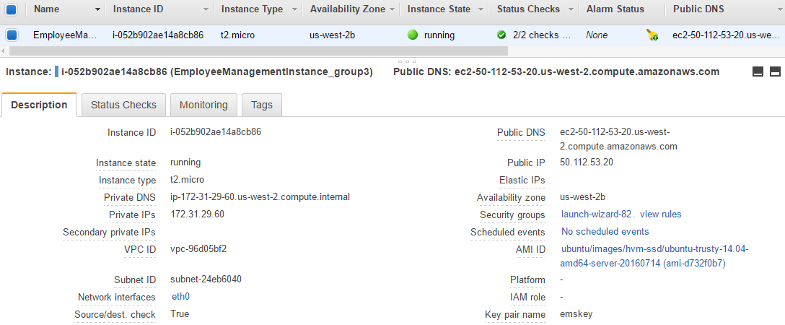

ELB